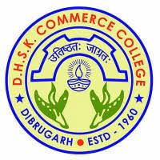 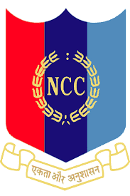

**NCC ENROLMENT PROCEDURE 2023-2024**

|  |  |  |  |  |
| --- | --- | --- | --- | --- |
| **STAGE WISE ENROLMENT CRITERIA** | | | | |
| **STAGE : 1**  PHYSICAL TEST | PARTICULARS | MALE | FEMALE | MARKS |
| Minimum Height | 160 cm | 152 cm | **20** |
| Running ( 1.5 km ) | 5 minutes | 7 minutes | **20** |
| 5 meters shuttle per minute | 12 rounds per minute | 10 rounds per minute | **10** |
| Push ups per minute | 20 times per minute | 15 times per minute | **15** |
| Sit ups per minutes | 25 times per minute | 20 times per minute | **15** |
| **STAGE: 2** WRITTEN TEST | Sl.no | Types of Questions | | |
| 1 | Multiple Choice Questions ( MCQ) ( general awareness on ncc, defence related including army, navy, and airforce ,arithmetic, mental aptitude) | | **50** |
| 2 | Thematic Apperception Test ( TAT) | | **10** |
| 3 | Word Association Test (WAT) | | **10** |
| 4 | Situation Response Test (SRT) | | **10** |
| **STAGE : 3**  CULTURAL AND OTHER CO-CURRICULAR ACTIVITIES TEST | Each students shall perform or showcase their cultural activities like bihu, shattriya dance etc and other activities in the form of dance or songs with traditional instruments | | | **20** |
| **STAGE : 4**  PERSONAL INTERVIEW | Each students shall face personal interview to be conducted by CO, PI STAFFS, ANO and senior cadets of the college NCC unit | | | **20** |
| **TOTAL MARKS** | | | | **200** |

**N/B: STUDENTS PERFORMING WELL IN ALL THE 4 STAGES SHALL BE FINALLY SELECTED**

**STUDENTS CAN COLLECT APPLICATION FORM FROM NCC OFFICE ON OR BEFORE 10TH AUG 2023**

**ANO**

**DHSK COMMERCE COLLEGE, DIBRUGARH**